**VISVESVARAYA TECHNOLOGICAL UNIVERSITY**

**JnanaSangama, Belgaum-590018**



**A Database Management System Mini Project Report**

**On**

**“EMPLOYEE LEAVE MANAGEMENT SYSTEM”**

**Submitted in Partial fulfillment of the Requirements for the V Semester of the Degree of**

**Bachelor of Engineering**

**In**

**Computer Science & Engineering**

**By**

**Aman Kumar**

**(1CR18CS016)**

**And**

**Ankit Yadav**

**(1CR18CS023)**

**Under the Guidance of**

**Mrs. Rubini P E**

**Asst. Professor, Dept. of CSE**



# DEPARTMENT OF Computer SCIENCE AND ENGINEERING

**CMR INSTITUTE OF TECHNOLOGY**

#132, AECS LAYOUT, IT PARK ROAD, KUNDALAHALLI,

BANGALORE-560037

**CMR INSTITUTE OF TECHNOLOGY**

1. #132, AECS LAYOUT, IT PARK ROAD, KUNDALAHALLI,
2. BANGALORE-560037

# DEPARTMENT OF Computer SCIENCE AND ENGINEERING

1. 

**CERTIFICATE**

This is to certify that the Database Management System Project work entitled **“EMPLOYEE LEAVE MANAGEMENT SYSTEM”** has been carried out by **Aman Kumar (1CR18CS016)** and **Ankit Yadav (1CR18CS023)** bonafide students of CMR Institute of Technology in partial fulfillment for the award of **Bachelor of Engineering** in **Computer Science and Engineering** of the Visvesvaraya Technological University, Belgaum during the year **2020-2021**. It is certified that all corrections/suggestions indicated for Internal Assessment have been incorporated in the Report deposited in the departmental library. This DBMS Project Report has been approved as it satisfies the academic requirements in respect of project work prescribed for the said degree.

**----------------------- ----------------------**

**Signature of Guide Signature of HOD**

**Mrs. Rubini PE Dr. Prem Kumar Ramesh**

**Asst. Professor Professor, Head**

**Dept. of CSE, CMRIT Dept. of CSE, CMRIT**

External Viva

Name of the examiners                                                                          Signature with date

1.

2.

**ABSTRACT**

In the world of businesses , maintaining the employee leave records on physical pen and paper may make tasks cumbersome and is complex to handle. It may also lead to mismatches and mistakes as human error is quite possible.

Therefore, through this website, we are completely digitizing the whole employee leave record management system , all the tasks involving in a leave record management system be it applying of leave, approval as well as status can be done using the website.

The aim of this project is to develop a website for all the businesses who are still functioning on non-digitized version of an Employee leave management and hence provide them a digitized version of the same.

**ACKNOWLEDGEMENT**

The success and final outcome of this project required a lot of guidance and assistance from many people and we are extremely privileged to have got this all along the completion of our project. All that we have done is only due to such supervision and assistance and we would not forget to thank them. We would like to extend our sincere esteems towards our guide, Mrs. Rubini PE for the support, guidance and encouragement, she provided during the BE Project. This work would have not been possible without her valuable time, patience and motivation. We thank her for making our stint thoroughly pleasant and enriching. We are deeply indebted to Prof. Mr. Prem Kumar Ramesh. (Head of Department of CSE) and the entire team in the Computer Department. They supported us with scientific guidance, advice and encouragement, they were always helpful and enthusiastic and this inspired us in our work. We take the privilege to express our sincere thanks to Dr. Sanjay Jain, our Principal for providing the encouragement and much support throughout our work.

AMAN KUMAR (1CR18CS016)

ANKIT YADAV (1CR18CS023)

**TABLE OF CONTENTS**

|  |  |  |
| --- | --- | --- |
|  | **Title** | **Page no.** |
| **1.** | List of Figures and Tables…………………………………... | IV |
| **2.** | Chapter1: Introduction………………………………………. | 1 |
| **3.** | Chapter 2: System Requirements……………………………. | 2 |
| **4.** | Chapter 3: Design…………………………………………… | 4 |
| **5.** | Chapter 4: Implementation………………………………….. | 6 |
| **6.** | Chapter 5: Discussion and Screenshots……………………... | 10 |
| **7.** | Chapter 6: Conclusion and Future Scope…………………… | 16 |
| **8.** | Chapter 7: Bibliography……………………………………... | 17 |

**List of Figures and Tables**

1. Table admin
   1. id
   2. Username
   3. password
   4. updationdate

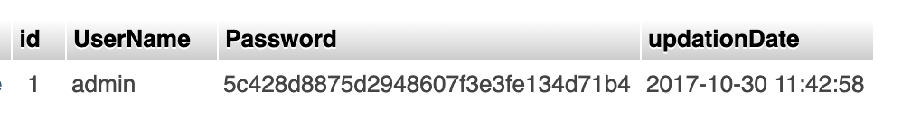

1. Table department
   1. id
   2. Departmentname
   3. DepartmentShortname
   4. DepartmentCode
   5. CreationDate

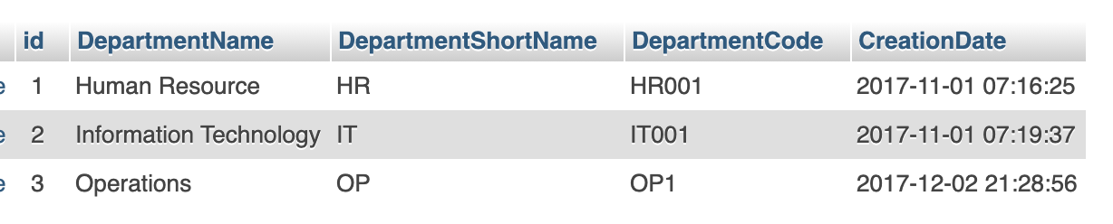

1. Table Leaves
   1. id
   2. leavetype
   3. Fromdate
   4. Todate
   5. description
   6. Postingdate
   7. Adminremark
   8. Status
   9. Isread
   10. EmpID

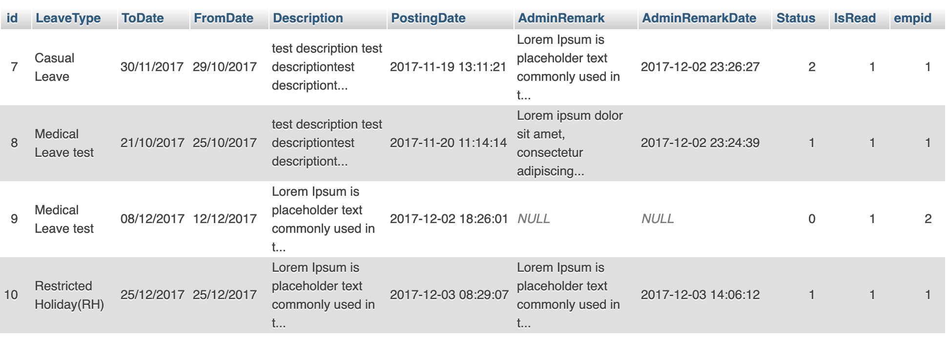

1. Table leavetype
   1. id
   2. LeaveType
   3. Description
   4. CreationDate

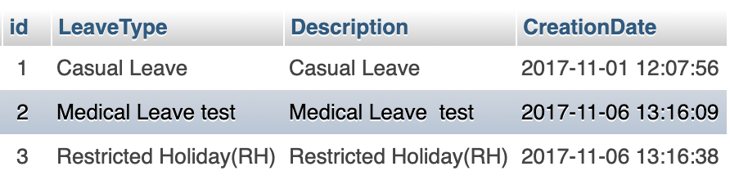

1. Table employee
   1. id
   2. Empid
   3. Firstname
   4. Lastname
   5. EmailId
   6. Password
   7. Gender
   8. Dateofbirth
   9. Department
   10. Address
   11. City
   12. Country
   13. PhoneNumber
   14. Status
   15. RegDate

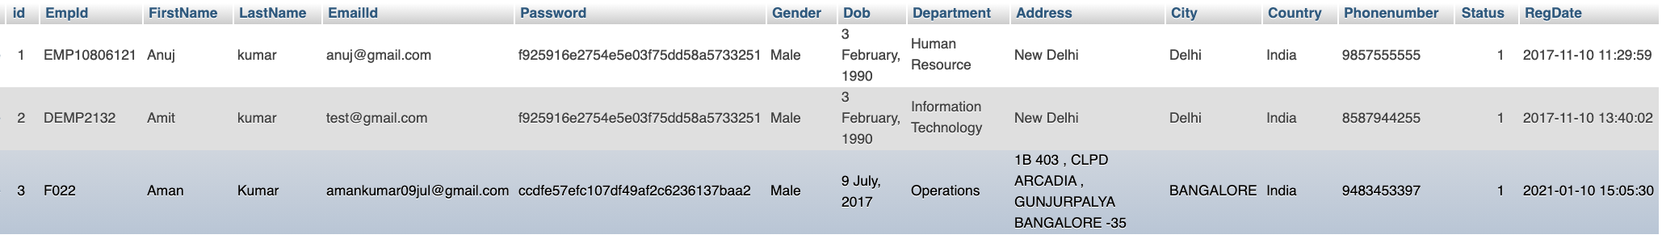

1. Table Resources
   1. EmpId
   2. Resources

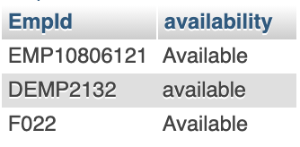

1. Trigger Employee_num
   1. Listedleavetype
   2. Total_registered
   3. Listed_departments

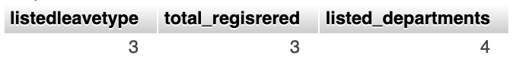

**Chapter 1**

**INTRODUCTION**

In the world of businesses , maintaining the employee leave records on physical pen and paper may make tasks cumbersome and is complex to handle. It may also lead to mismatches and mistakes as human error is quite possible. Therefore, through this website, we are completely digitizing the whole employee leave record management system , all the tasks involving in a leave record management system be it applying of leave, approval as well as status can be done using the website.

To make this possible, we have developed an application where the admin and employee both can login, and the employee can apply for the leaves as well the admin can take care of all the leave details such as reviewing, approving the leaves and seeing all the statuses.

**Chapter 2**

**SYSTEM REQUIREMENTS**

**2.1 Functional Requirements**

Our Web Application, ‘Employee Leave Management System’ is made for the Employees where they can apply for leave. The knowledge required for this project was - HTML, CSS ,PHP and little about JavaScript.

The functional requirements of our project are:

• The website contains a Login page, Dashboard, Department, Employees,Resources and Leaves of Employees.

• When the user accesses the website, he/she is directed to the Login Page, where admin enters its username and password, and a dashboard which shows all the Total registered employee, listed department, listed leave type.

• The leave is categorized according to its type should be filtered according to its type. The leave types are:- Casual type, Medical Type, Restricted Type.

• Admin can take actions on the leave , Admin can approve or reject the leave of Employees.

• Admin has authority to add employee or remove it from the department.

• The Page contains all the leaves applied by the employees.

• Employee has an option to add description to the leave.

• While applying leave employee has to select the dates from which to which date he/she wants leave.

• When admin takes the action on employee leave, the action is reflected on the employees portal.

• Admin also has the privilege to see all the temporary resources who are available for working against the employees that are on leave .

• Also each employee login page has the feature wherein the employee can change his status to available or unavailable for the Temporary resources pool.

**2.2 Hardware and Software Requirements**

**2.1 System Requirements**

These consist of the hardware and software components of a computer system that are required to install in order to use the software efficiently.

* + 1. **Software Requirements**

1. **Operating system**: Windows XP / windows 7
2. **Technology:** PHP
3. **Database:** MySQL
4. **IDE:** VS CODE
5. Antivirus software
6. Backup & Data Recovery software
   * 1. **Hardware Requirements**
7. **Processor:** Intel dual core or above
8. **Processor Speed:**1.0GHZ or above
9. **RAM:**1 GB RAM or above
10. **Hard Disk:**20 GB hard disk or above
11. Printer for printing reports
12. Uninterruptible power supply to ensure a constant access of data.
13. USB flash disk (At least 2GB)

**Chapter 3**

**DESIGN**

3.1 ER Diagram

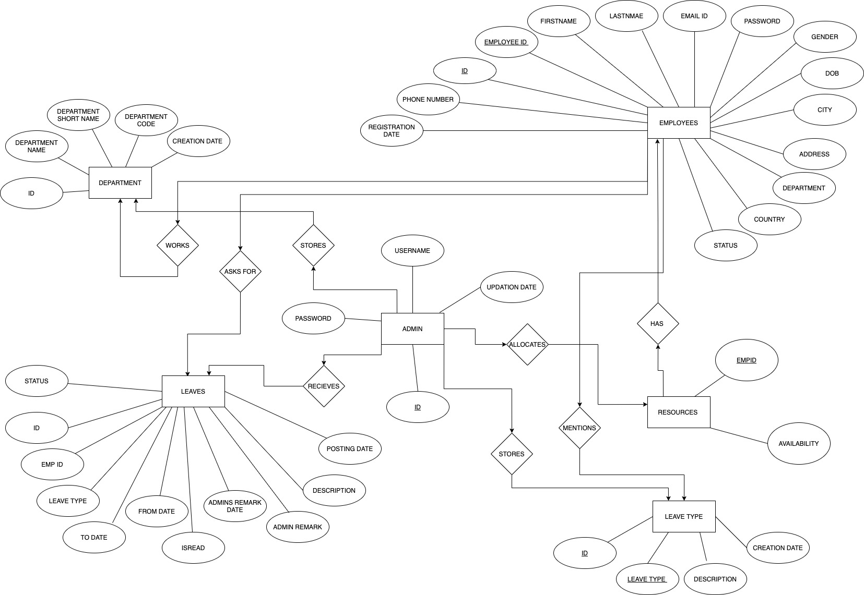

In the above ER-Diagram we have five entities (1)admin, (2)department, (3)leavetype, (4)leaves, (5)employee (6)resources and their relationship. Each entity has its own attributes.

The entity admin consists the details of the admin as its attributes, core_item consists of details that are to be handled by the admin. The employee asks for leave types that are already listen in the leavetypes table. The department and employee consists of details about each department and the details of all the employee present in the organization respectively.

The relation between leaves and employee is one to many relationship as one leavetype can be applied multiple employees.

3.2 Schema Diagram

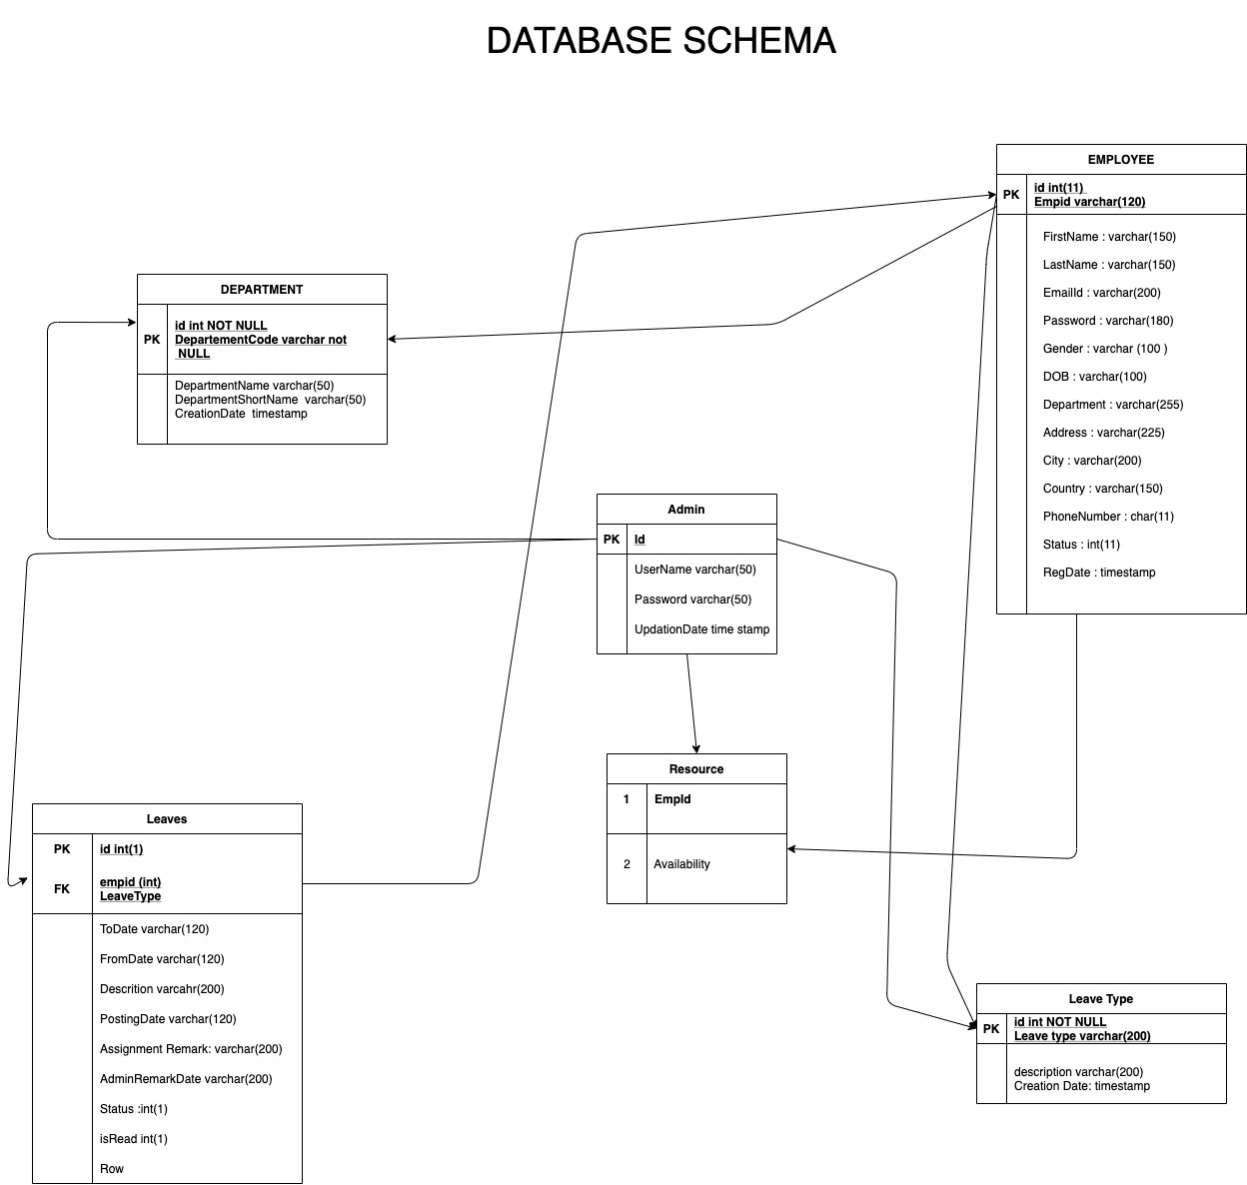

**Chapter 4**

**IMPLEMENTATION**

Dashboard.php :

<?php

session_start();

error_reporting(0);

include('includes/config.php');

if(strlen($_SESSION['alogin'])==0)

{

header('location:index.php');

}

else{

?>

<!DOCTYPE html>

<html lang="en">

<head>

*<!-- Title -->*

<title>Admin | Dashboard</title>

<meta name="viewport" content="width=device-width, initial-scale=1.0, maximum-scale=1.0, user-scalable=no"/>

<meta charset="UTF-8">

<meta name="description" content="Responsive Admin Dashboard Template" />

<meta name="keywords" content="admin,dashboard" />

<meta name="author" content="Steelcoders" />

*<!-- Styles -->*

<link type="text/css" rel="stylesheet" href="../assets/plugins/materialize/css/materialize.min.css"/>

<link href="http://fonts.googleapis.com/icon?family=Material+Icons" rel="stylesheet">

<link href="../assets/plugins/metrojs/MetroJs.min.css" rel="stylesheet">

<link href="../assets/plugins/weather-icons-master/css/weather-icons.min.css" rel="stylesheet">

*<!-- Theme Styles -->*

<link href="../assets/css/alpha.min.css" rel="stylesheet" type="text/css"/>

<link href="../assets/css/custom.css" rel="stylesheet" type="text/css"/>

</head>

<body>

<?php include('includes/header.php');?>

<?php include('includes/sidebar.php');?>

<main class="mn-inner">

<div class="middle-content">

<div class="row no-m-t no-m-b">

<div class="col s12 m12 l4">

<div class="card stats-card">

<div class="card-content">

<span class="card-title">Totle Regd Employee</span>

<span class="stats-counter">

<?php

$sql = "SELECT id from tblemployees";

$query = $dbh -> prepare($sql);

$query->execute();

$results=$query->fetchAll(PDO::FETCH_OBJ);

$empcount=$query->rowCount();

?>

<span class="counter"><?php echo htmlentities($empcount);?></span></span>

</div>

<div id="sparkline-bar"></div>

</div>

</div>

<div class="col s12 m12 l4">

<div class="card stats-card">

<div class="card-content">

<span class="card-title">Listed Departments </span>

<?php

$sql = "SELECT id from tbldepartments";

$query = $dbh -> prepare($sql);

$query->execute();

$results=$query->fetchAll(PDO::FETCH_OBJ);

$dptcount=$query->rowCount();

?>

<span class="stats-counter"><span class="counter"><?php echo htmlentities($dptcount);?></span></span>

</div>

<div id="sparkline-line"></div>

</div>

</div>

<div class="col s12 m12 l4">

<div class="card stats-card">

<div class="card-content">

<span class="card-title">Listed leave Type</span>

<?php

$sql = "SELECT id from tblleavetype";

$query = $dbh -> prepare($sql);

$query->execute();

$results=$query->fetchAll(PDO::FETCH_OBJ);

$leavtypcount=$query->rowCount();

?>

<span class="stats-counter"><span class="counter"><?php echo htmlentities($leavtypcount);?></span></span>

</div>

<div class="progress stats-card-progress">

<div class="determinate" style="width: 70%"></div>

</div>

</div>

</div>

</div>

<div class="row no-m-t no-m-b">

<div class="col s12 m12 l12">

<div class="card invoices-card">

<div class="card-content">

<span class="card-title">Latest Leave Applications</span>

<table id="example" class="display responsive-table ">

<thead>

<tr>

<th>#</th>

<th width="200">Employe Name</th>

<th width="120">Leave Type</th>

<th width="180">Posting Date</th>

<th>Status</th>

<th align="center">Action</th>

</tr>

</thead>

<tbody>

<?php $sql = "SELECT tblleaves.id as lid,tblemployees.FirstName,tblemployees.LastName,tblemployees.EmpId,tblemployees.id,tblleaves.LeaveType,tblleaves.PostingDate,tblleaves.Status from tblleaves join tblemployees on tblleaves.empid=tblemployees.id order by lid desc limit 6";

$query = $dbh -> prepare($sql);

$query->execute();

$results=$query->fetchAll(PDO::FETCH_OBJ);

$cnt=1;

if($query->rowCount() > 0)

{

foreach($results as $result)

{

?>

<tr>

<td> <b><?php echo htmlentities($cnt);?></b></td>

<td><a href="editemployee.php?empid=<?php echo htmlentities($result->id);?>" target="_blank"><?php echo htmlentities($result->FirstName." ".$result->LastName);?>(<?php echo htmlentities($result->EmpId);?>)</a></td>

<td><?php echo htmlentities($result->LeaveType);?></td>

<td><?php echo htmlentities($result->PostingDate);?></td>

<td><?php $stats=$result->Status;

if($stats==1){

?>

<span style="color: green">Approved</span>

<?php } if($stats==2) { ?>

<span style="color: red">Not Approved</span>

<?php } if($stats==0) { ?>

<span style="color: blue">waiting for approval</span>

<?php } ?>

</td>

<td>

<td><a href="leave-details.php?leaveid=<?php echo htmlentities($result->lid);?>" class="waves-effect waves-light btn blue m-b-xs" > View Details</a></td>

</tr>

<?php $cnt++;} }?>

</tbody>

</table>

</div>

</div>

</div>

</div>

</div>

</main>

</div>

*<!-- Javascripts -->*

<script src="../assets/plugins/jquery/jquery-2.2.0.min.js"></script>

<script src="../assets/plugins/materialize/js/materialize.min.js"></script>

<script src="../assets/plugins/material-preloader/js/materialPreloader.min.js"></script>

<script src="../assets/plugins/jquery-blockui/jquery.blockui.js"></script>

<script src="../assets/plugins/waypoints/jquery.waypoints.min.js"></script>

<script src="../assets/plugins/counter-up-master/jquery.counterup.min.js"></script>

<script src="../assets/plugins/jquery-sparkline/jquery.sparkline.min.js"></script>

<script src="../assets/plugins/chart.js/chart.min.js"></script>

<script src="../assets/plugins/flot/jquery.flot.min.js"></script>

<script src="../assets/plugins/flot/jquery.flot.time.min.js"></script>

<script src="../assets/plugins/flot/jquery.flot.symbol.min.js"></script>

<script src="../assets/plugins/flot/jquery.flot.resize.min.js"></script>

<script src="../assets/plugins/flot/jquery.flot.tooltip.min.js"></script>

<script src="../assets/plugins/curvedlines/curvedLines.js"></script>

<script src="../assets/plugins/peity/jquery.peity.min.js"></script>

<script src="../assets/js/alpha.min.js"></script>

<script src="../assets/js/pages/dashboard.js"></script>

</body>

</html>

<?php } ?>

**Trigger :**

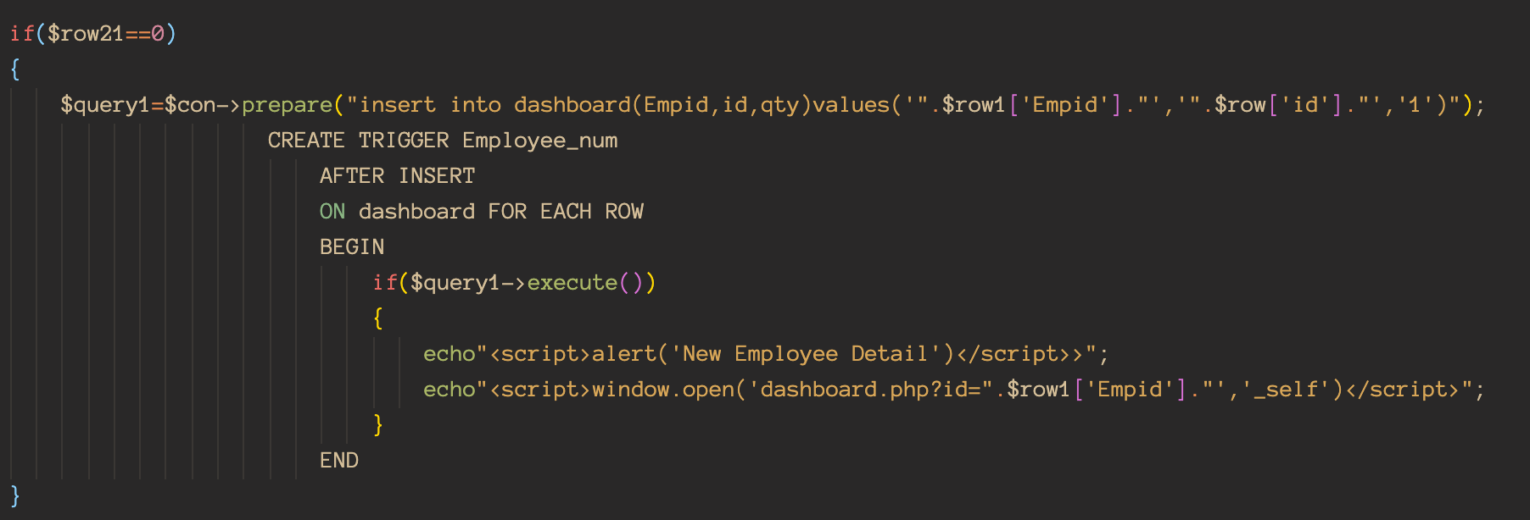

**Stored Procedure :**

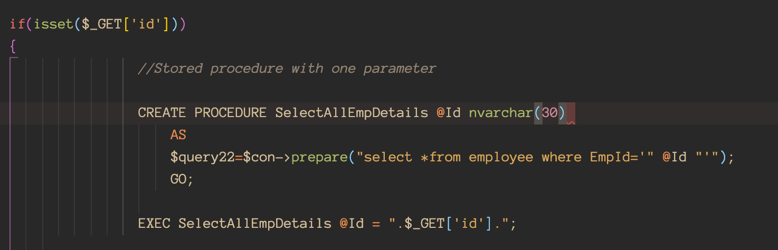

**Chapter 5**

**DISCUSSION AND SCREENSHOTS**

**Fig. 5.1 Admin Login Page**



**Fig. 5.2 Dashboard**



**Fig. 5.3 Department**



**Fig. 5.4 Leave Management**



**Fig. 5.5 Apply leave Page**



**Fig. 5.6 Change Password**



**Fig. 5.7 Resources Page Admin End**

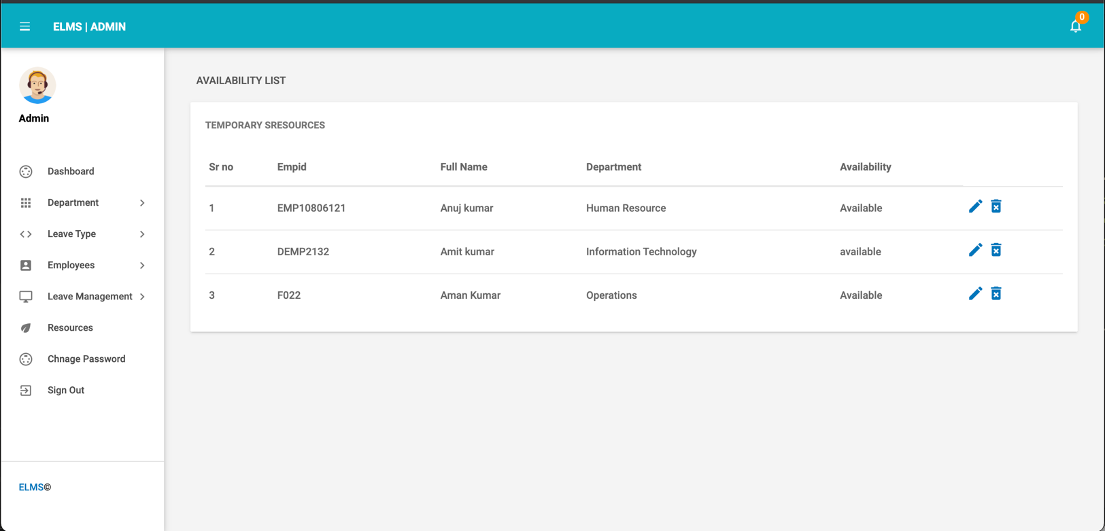

**Fig. 5.8 Resources Page Employee End**

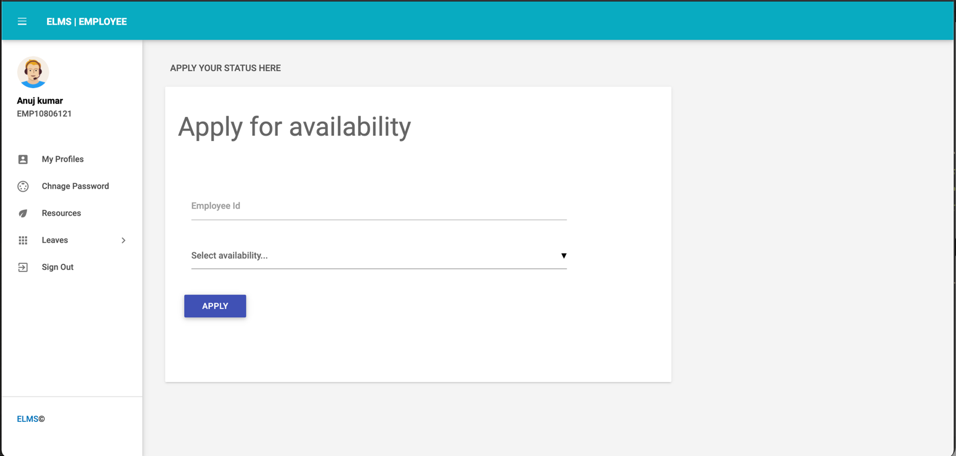

**Fig. 5.9 Employee Login**



**Chapter 6**

**CONCLUSION AND FUTURE SCOPE**

**6.1 Conclusion**

Our aim in this project ‘Employee Leave Management System’ to help the businesses with there leave management system and digitize the whole user interface. From our project, we learnt to create a fully developed and working Web Application from scratch. Our team enjoyed every step and endeavored to complete the task at hand.

**6.2 Future Scope**

In the future we can implement dynamic leave status granting using machine learning for giving automatic system approved choices .

**BIBLIOGRAPHY**

[1] Web Development using PHP Guide

[2] GeeksForGeeks

[3] MYSql Guide

[4] https://www.w3schools.com/sql/